MANGO (Mangifera indica)

Powdery mildew

**Disease symptoms**

* The characteristic symptom of the disease is the white superficial powdery fungal growth on leaves, stalks of panicles, flowers and young fruits.
* The affected flowers and fruits drop pre-maturely reducing the crop load considerably or might even prevent the fruit set.
* The fungus parasitizes young tissues of all parts of the inflorescence, leaves and fruits.
* Young leaves are attacked on both the sides but it is more conspicuous on the grower surface. Often these patches coalesce and occupy larger areas turning into purplish brown in colour

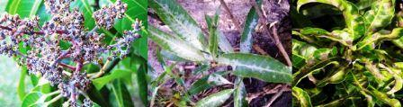

**Survival and spread**

* The powdery mildew fungus overwinters in dormant buds. When conditions are favorable for growth of the fungus in spring, spores are produced, released, and cause new infections. Secondary spread of the disease can occur if spores are produced in these new infections

**Favourable conditions**

* Rains or mists accompanied by cooler nights during flowering are congenial for the disease spread.

Anthracnose/Blossom Blight

**Disease symptoms**

* The disease causes serious losses to young shoots, flowers and fruits It is also affects fruits during storage.
* The disease produces leaf spot, blossom blight, wither tip, twig blight and fruit rot symptoms. Tender shoots and foliage are easily affected which ultimately cause „die back‟ of young branches. Older twigs may also be infected through wounds which in severe cases may be fatal.
* Depending on the prevailing weather conditions blossom blight may vary in severity from slight to a heavy infection of the panicles. Black spots develop on panicles as well as on fruits. Severe infection destroys the entire inflorescence resulting in no setting of fruits. Young infected fruits develop black spots, shrivel and drop off.
* Fruits infected at mature stage carry the fungus into storage and cause considerable loss during storage, transit and marketing.

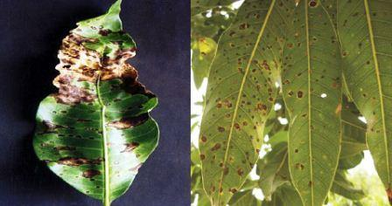

**Survival and spread**

* Fungus survives in dead twig and other host for long time which is the source of primary infection.

**Favorable conditions**

* High humidity, frequent rains and a temperature of 24-32oC favors the development of disease.

Die back

**Disease symptoms**

* The pathogen causing dieback, tip dieback, graft union blight, twig blight, seedling rot, wood stain, stem-end rot, black root rot, fruit rot, dry rot, brown rot of panicle etc. The disease is most conspicuous during October November.
* It is characterized by drying back of twigs from top downwards, particularly in older trees followed by drying of leaves which gives an appearance of fire scorch. Internal browning in wood tissue is observed when it is slit open along with the long axis.
* Cracks appear on branches and gum exudes before they die out. When graft union of nursery plant is affected, it usually dies

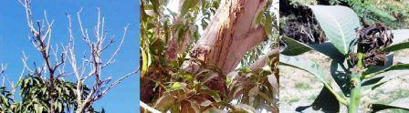

**Survival and spread**

* Pathogens survive in plant debris which is the source of primary inoculums.

**Favourable conditions**

* High humidity and moist conditions favours the development of disease. The disease is most common in October-November.

Phoma blight

**Disease symptom**

* The symptoms of the disease are noticeable only on old leaves. Initially, the lesions are angular, minute, irregular, yellow to light brown, scattered over leaf lamina.
* As the lesions enlarge their colour changes from brown to cinnamon and they become almost irregular.
* Fully developed spots are characterized by dark margins and dull grey necrotic centres. In case of severe infection such spots coalesce forming patches measuring 3.5-13 cm in size, resulting in complete withering and defoliation of infected leaves.

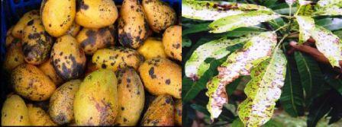

**Survival and spread**

* The pathogen is seed borne fungus and inoculums present in the seeds are source of primary infection. Fungus also survives on glumes, fruit and plant debris.

**Favourable conditions**

* Rainy seasons favour the development of disease.

Bacterial canker

**Disease symptoms**

* The disease is noticed on leaves, leaf stalks, stems, twigs, branches and fruits, initially producing water soaked lesions, later turning into typical canker.
* On leaves, water soaked irregular satellite to angular raised lesions measuring 1-4 mm in diameter are formed. These lesions are light yellow in colour, initially with yellow halo but with age enlarge or coalesce to form irregular necrotic cankerous patches with dark brown colour.
* On fruits, water-soaked, dark brown to black coloured lesions are observed which gradually developed into cankerous, raised or flat spots. These spots grow bigger usually up to 1 to 5 mm in diameter, which covers / almost the whole fruit.
* These spots often, burst extruding gummy substances containing highly contagious bacterial cells.

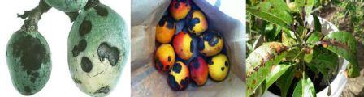

**Survival and spread**

* In lesions on plant parts and can also survive for long periods in diseased plant tissues.

**Favourable conditions**

* Spring session is responsible for the development of diseases.

Red rust

**Disease symptoms**

* Red rust disease, caused by an alga, has been observed in mango growing areas. The algal attack causes reduction in photosynthetic activity and defoliation of leaves thereby lowering vitality of the host plant.
* The disease can easily be recognized by the rusty red spots mainly on leaves and sometimes on petioles and bark of young twigs and is epiphytic in nature.
* The spots are greenish grey in colour and velvety in texture. Later, they turn reddish brown. The circular and slightly elevated spots sometimes coalesce to form larger and irregular spots. The disease is more common in closely planted orchards.

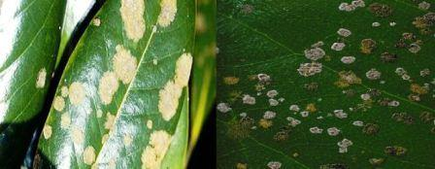

**Survival and spread**

* The pathogens reproduce and survive in spots on leaves or stems and in fallen plant host debris.

**Favourable conditions**

* Frequent rains and warm weather are favorable conditions for these pathogens. For hosts, poor plant nutrition, poor soil drainage, and stagnant air are predisposing factors to infection by the algae

Sooty mould

**Disease symptoms**

* The disease is common in the orchards where mealy bug, scale insect and hopper are not controlled efficiently.
* The disease in the field is recognized by the presence of a black velvety coating, i.e., sooty mould on the leaf surface. In severe cases the trees turn completely black due to the presence of mould over the entire surface of twigs and leaves.
* The severity of infection depends on the honey dew secretion by the above said insects. Honey dew secretions from insects sticks to the leaf surface and provide necessary medium for fungal growth.

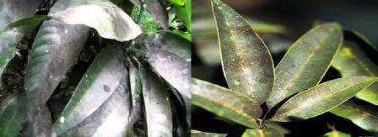

**Survival and spread**

* The severity of infection depends on the honey dew secretions by the scale insects which provide the necessary medium for the fungal growth.
* Transmission occurs by air-borne as co-spores.

**Favourable conditions**

* High humidity and moist situation favours the development of disease.

Mango malformation

**Disease symptoms**

* Vegetative malformation: Vegetative malformation is pronounced in young seedlings. The affected seedlings develop vegetative growths which are abnormal growth, swollen and have very short internodes.
* Floral malformation: The flower buds are transformed into vegetative buds and a large number of small leaves and stems, which are characterized by appreciably reduced internodes and give an appearance of witches‟ broom. The flower buds seldom open and remain dull green.

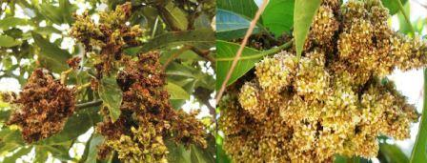

**Survival and spread**

* The disease is mainly spread via infected plant material. Mango malformation disease spreads slowly within affected orchards.
* The mango bud mite, Aceria mangiferae, has been associated with mango malformation disease as wounds from the mites‟ feeding activity are thought to facilitate fungal infection.

**Favourable conditions**

* Moist weather favours the development of disease.

# TOMATO DISEASES & DISORDERS

Factsheet | HGIC 2217 | **Updated:** Jul 23, 2020 | [**Print**](javascript:window.print()) | [**Download (PDF)**](https://drive.google.com/file/d/11Bwmb8rvNVLRrI3vQHhprxsYQmfdNgAA/view?usp=sharing)

Tomatoes (Solanum lycopersicum) can be grown on almost any moderately well-drained soil type. A good supply of organic matter can increase yield and reduce production problems. Tomatoes and related vegetables, such as potatoes, peppers and eggplants, should not be planted on the same land more than once in three years.

## Early Blight

**[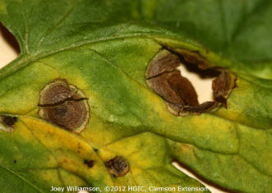](http://clemsonhgic.wpengine.com/wp-content/uploads/2018/03/early-blight-alternaria-solani-on-tomato-foliage.jpeg)**

Early blight (Alternaria solani) on tomato foliage.  
Joey Williamson, ©2012 HGIC, Clemson Extension

This disease is caused by the fungi Alternaria tomatophila and A. solani and is first observed on the plants as small, brown lesions mostly on the older foliage. Spots enlarge and concentric rings in a bull’s-eye pattern may be seen in the center of the diseased area. Tissue surrounding the spots may turn yellow. If high temperature and humidity occur at this time, much of the foliage is killed. Lesions on the stems are similar to those on leaves and sometimes girdle the plant if they occur near the soil line (collar rot). On the fruits, lesions attain considerable size, usually involving nearly the entire fruit. Concentric rings are also present on the fruit. Infected fruit frequently drops.

**Prevention & Treatment:** Use resistant or tolerant tomato cultivars. Use pathogen-free seed and do not set diseased plants in the field. Use crop rotation, eradicate weeds and volunteer tomato plants, space plants to not touch, mulch plants, fertilize properly, don’t wet tomato plants with irrigation water, and keep the plants growing vigorously. Trim off and dispose of infected lower branches and leaves.To reduce disease severity, test the garden soil annually and maintain a sufficient level of potassium. Side dress tomato plants monthly with calcium nitrate for adequate growth.

If disease is severe enough to warrant chemical control, select one of the following fungicides: mancozeb (very good); chlorothalonil or copper fungicides (good). Follow the directions on the label. See Table 1 for examples of fungicide products for home garden use. See Table 2 for tomato cultivars with resistance or tolerance to early blight.

## Septoria Leaf Spot

**[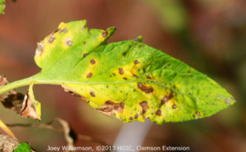](http://clemsonhgic.wpengine.com/wp-content/uploads/2018/03/septoria-leaf-spot-septoria-lycopersici-on-tomat.jpeg)**

Septoria leaf spot (Septoria lycopersici) on tomato.  
Joey Williamson, ©2013 HGIC, Clemson Extension

This destructive disease of tomato foliage, petioles and stems (fruit is not infected) is caused by the fungus Septoria lycopersici. Infection usually occurs on the lower leaves near the ground, after plants begin to set fruit. Numerous small, circular spots with dark borders surrounding a beige-colored center appear on the older leaves. Tiny black specks, which are spore-producing bodies, can be seen in the center of the spots. Severely spotted leaves turn yellow, die and fall off the plant. The fungus is most active when temperatures range from 68 to 77° F, the humidity is high, and rainfall or over-head irrigation wets the plants. Defoliation weakens the plant, reduces the size and quality of the fruit, and exposes the fruit to sunscald (see below). The fungus is not soil-borne, but can overwinter on crop residue from previous crops, decaying vegetation and some wild hosts related to tomato.

**Prevention & Treatment:** Currently grown tomato cultivars are susceptible to Septoria leaf spot. Crop rotation of 3 years and sanitation (removal of crop debris) will reduce the amount of inoculum. Do not use over-head irrigation. Repeated fungicide applications with chlorothalonil (very good) or copper fungicide, or mancozeb (good) will keep the disease in check. See Table 1 for examples of fungicide products for home garden use.

## Bacterial Spot

**[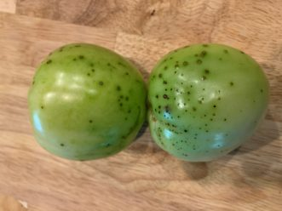](https://171dxwjpaqv2danpq11ixf2j-wpengine.netdna-ssl.com/wp-content/uploads/2018/12/bac-spot-fruit-scaled.jpg)**

“Bacterial Spot symptoms can be seen on both foliage and tomato fruit under ideal conditions.”  
Zack Snipes, ©2020, Clemson Extension

This disease is caused by the bacterium Xanthomonas vesicatoria, which attacks green but not red tomatoes. Peppers are also attacked. The disease is more prevalent during wet seasons. Damage to the plants includes leaf and fruit spots, which result in reduced yields, defoliation and sun- scalded fruit. The symptoms consist of numerous small, angular to irregular, water-soaked spots on the leaves and slightly raised to scabby spots on the fruits. The leaf spots may have a yellow halo. The centers dry out and frequently tear.

**[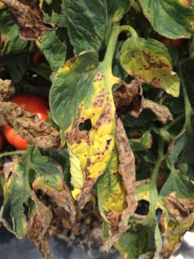](http://clemsonhgic.wpengine.com/wp-content/uploads/2018/03/bacterial-spot-xanthomonas-vesicatoria-symptoms.jpeg)**

Bacterial Spot (Xanthomonas vesicatoria) symptoms on tomato leaves.  
Zachary Boone Snipes, ©2015 Clemson Extension

The bacteria survive the winter on volunteer tomato plants and on infected plant debris. Moist weather is conducive to disease development. Most outbreaks of the disease can be traced back to heavy rainstorms that occurred in the area. Infection of leaves occurs through natural openings. Infection of fruits must occur through insect punctures or other mechanical injury.

Bacterial spot is difficult to control once it appears in the field. Any water movement from one leaf or plant to another, such as splashing rain drops, overhead irrigation, and touching or handling wet plants, may spread the bacteria from diseased to healthy plants.

**Prevention & Treatment:**Only use certified disease-free seed and plants. Avoid areas that were planted with peppers or tomatoes during the previous year. Avoid overhead watering by using drip or furrow irrigation. Remove all diseased plant material. Prune plants to promote air circulation. Spraying with a copper fungicide will give fairly good control the bacterial disease. Follow the instructions on the label. See Table 1 for fungicide products for home garden use.

## Tomato Yellow Leaf Curl Virus (TYLCV)

TYLCV is not seed-borne, but is transmitted by whiteflies. This disease is extremely damaging to fruit yield in both tomato and pepper crops. Whiteflies may bring the disease into the garden from infected weeds nearby, such as various nightshades and jimsonweed. After infection, tomato plants may be symptomless for as long as 2 – 3 weeks.

**[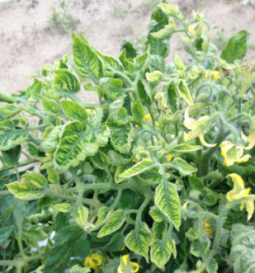](http://clemsonhgic.wpengine.com/wp-content/uploads/2018/03/tomato-plant-with-tomato-yellow-leaf-curl-virus-.jpeg)**

Tomato plant with Tomato yellow leaf curl virus.  
Zachary Boone Snipes, ©2015 Clemson Extension

Symptoms in tomato plants are the upward curling of leaves, yellow (chlorotic) leaf margins, smaller leaves than normal, plant stunting, and flower drop. If tomato plants are infected early in their growth, there may be no fruit formed. Infected plants may appear randomly throughout the garden. Pepper plants may also become infected, but will show no symptoms.

**Prevention & Treatment:** Removal of plants with initial symptoms may slow the spread of the disease. Rogued (pulled out) infected plants should be immediately bagged to prevent the spread of the whiteflies feeding on those plants. Keep weeds controlled within and around the garden site, as these may be alternate hosts for whiteflies. Reflective mulches (aluminum or silver-colored) can be used in the rows to reduce whitefly feeding.

Low concentration sprays of a horticultural oil or canola oil will act as a whitefly repellent, reduce feeding and possibly transmission of the virus. Use a 0.25 to 0.5% oil spray (2 to 4 teaspoons horticultural or canola oil & a few drops of dish soap per gallon of water) weekly. Examples of products containing horticultural oil are Ferti-lome Horticultural Oil Spray and Bonide All Seasons Spray Oil. Example of a product containing canola oil is Espoma Earth-tone Horticultural Oil Ready to Spray.

At the end of the season, remove all susceptible plants and burn or dispose of them. See Table 6 for tomato cultivars with resistance to Tomato yellow leaf curl virus.

|  |  |
| --- | --- |
| **Fungicide Active Ingredient** | **Examples of Products Containing the Active Ingredient** |
| **Chlorothalonil** | Bonide Fungonil Concentrate (29.6%) Ferti-lome Broad Spectrum Landscape & Garden Fungicide Conc. (12.5%) GardenTech Daconil Fungicide Concentrate (29.6%) Hi-Yield Vegetable, Flower, Fruit & Ornamental Fungicide Conc. (12.5%) Ortho MAX Garden Disease Control Concentrate (29.6%) Southern Ag Liquid Ornamental & Vegetable Fungicide Conc. (12.5%) Tiger Brand Daconil Concentrate (12.5%) |
| **Mancozeb** | Bonide Mancozeb Flowable with Zinc Concentrate Southern Ag Dithane M-45 |
| **Copper Fungicide2** | Natural Guard Copper Soap Liquid Fungicide Concentrate (1.8%) Bonide Liquid Copper Concentrate (a copper soap) (1.8%) Camelot Fungicide/ Bactericide Concentrate (a copper soap) (1.8%) Bonide Copper Fungicide (7%) Monterey Liqui-Cop Fungicide Concentrate (8%) Southern Ag Liquid Copper Fungicide (8%) |
| 1RTU products are pre-mixed fungicides in a spray bottle. 2For copper fungicides, the greater the metallic copper content, the better the control of bacterial & fungal diseases. | |

**Table 1. Fungicide Products for Home Garden Disease Control on Tomatoes.**

**Table 2. Tomato Cultivars with Resistance to Early Blight.**

|  |  |  |  |
| --- | --- | --- | --- |
| **Tomato Cultivar** | **Other Disease Resistance\*** | **Plant Growth Habit\*\*** | **Days to Ripeness** |
| Mountain Supreme Hybrid | VF | D | 69-70 |
| Mountain Fresh Hybrid | VFF | D | 77 |
| Mountain Magic Hybrid | VFF | ISI | 72 |
| Plum Regal Hybrid | VFF | D | 72 |
| Plum Dandy Hybrid | VF | ISI | 82 |
| Cabernet Hybrid | VFF | I | 60 |
| Manalucie | FSt | I | 82 |
| Merlot Hybrid | VFF | I | 59 |
| Tommy Toe (cherry) | none | I | 70 |
| Mountain Merit Hybrid (moderate EB resist.) | VFFFN TSWV LB | D | 75 |
| Jasper Hybrid (cherry) | FF LB S | D | 60 |
| Iron Lady Hybrid | LB S | D | 77 |
| Matt’s Wild Cherry (moderate EB resistance) | LB (moderate) | I | 60 |
| Juliet Hybrid (mini-roma) (moderate EB resist) | none | I | 60 |
| Defiant PhR Hybrid (moderate EB resistance) | VFF LB | D | 70 |
| Legend (moderate EB resistance) | LB | D | 68 |
| Old Brooks (moderate EB resistance) | LB | I | 78 |

**Table 6. Tomato Cultivars with Resistance to *Tomato Yellow Leaf Curl Virus* (TYLCV).**

|  |  |  |  |
| --- | --- | --- | --- |
| **Tomato Cultivar** | **Other Disease Resistance\*** | **Plant Growth Habit\*\*** | **Days to Ripeness** |
| Champion II Hybrid | VFFNTA | I | 62-65 |
| Charger Hybrid | VFFFASt | D | 76 |
| Margo Hybrid | VFFT | D | 70 |

**Flowering plants**

Most flowers are hardy plants that aren’t bothered by disease when they are properly fed and watered. However, sometimes various flower diseases are transmitted from infected plants or triggered by uncooperative weather conditions.

Many diseases are curable, but unfortunately, some are deadly. Read on to learn about the 10 most common flower diseases and what you can do to minimize the risk.

## **Botrytis blight**

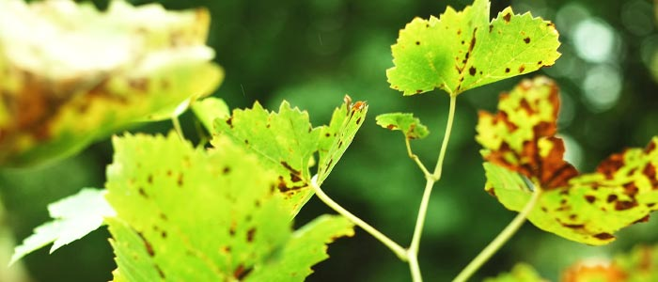

This fungal disease, sometimes known as grey mold, begins with fluffy, gray, white or tan growth on flowers, soon spreading to the stalks and causing plants to become dry and brittle. Botrytis blight is usually controlled with improved growing conditions and sanitation. If the problem is severe,**try a fungicide registered for use against botrytis.**

## **Powdery mildew**

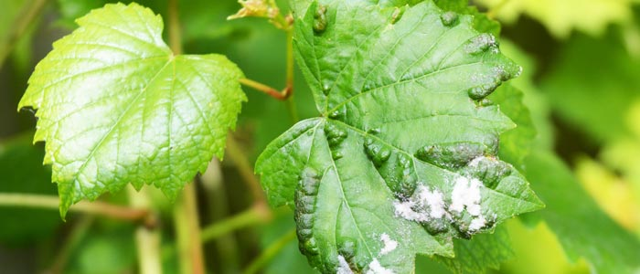

Plants with powdery mildew look like they have been dusted with a gray or white powder. Although the fungus is unsightly and may return every year, it is fatal only in extreme cases. Although you can **use fungicide, a spray made of baking soda, liquid dish soap, vegetable oil, and water** is safer and may be just as effective.

## **Sooty mold**

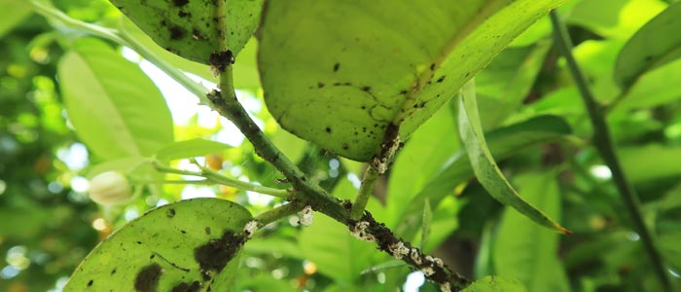

Leaves and stems of plants with sooty mold are speckled with a thin black film that is easily wiped off with your fingers. The mold is attracted to the sweet “honeydew” left behind by aphids and other sucking insects. The first step is to control pests, and **insecticidal soap is often highly effective**. Neem oil is effective against both pests and sooty mold.

## **Root rot**

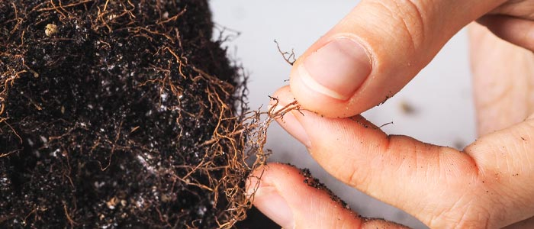

This soil-borne fungus causes stunted growth and wilted, shriveled leaves. Roots of an affected plant often display a wet, rotten appearance and a foul smell. Some may display stringy brown or black strands. Root rot is often fatal, but **fungicides may help** if applied early enough.

Root Rots Caused by various soilborne pathogens

Root Rot • Caused by soilborne pathogens that attack roots • Roots may be discolored internally or externally • Symptoms may include wilting, stunting, yellowing

Root rot Symptoms vary, depending on the pathogen. Some root rot diseases cause a light brown discoloration on roots. Roots may be mushy or not. Others cause distinct, dark reddish-brown lesions on roots.

**Root Rot Management**

**Prevention**: Select and plant healthy material

Plant in well drained soils

Don’t over water

“Hill up” infected plants to promote adventitious root production above rotted area.

## **Leaf spot**

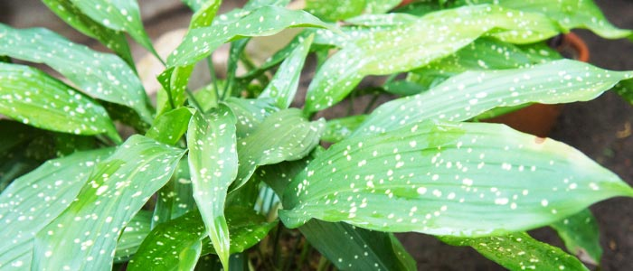

Affected leaves display small yellow spots that eventually turn brown, often surrounded with a yellow or brownish-black ring. Leaf spot isn’t curable, but a **fungicide or a mixture of baking soda, vegetable oil, liquid dish soap and water** may slow spread by preventing spores from germinating.

## **Fire blight**

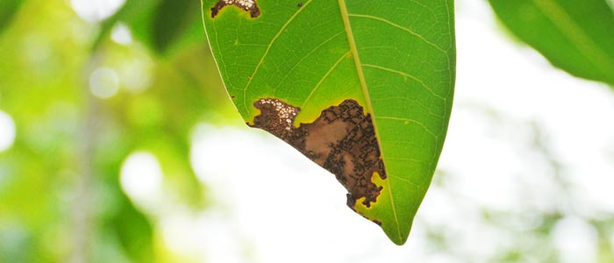

This bacterial disease usually affects fruit trees, showing up with brown and shriveled flowers first, followed by leaves turning black or brown. Cankers may show up on branches.The disease, which is favored by rainy, warm weather usually starts on the upper part of the plant and progresses downward. The disease is difficult to control, but copper-based products may help. **Remove and destroy affected branches.**

## **Black spot**

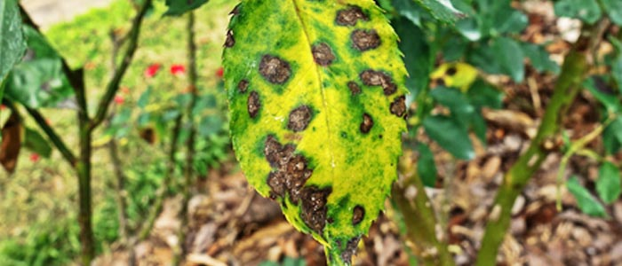

Primarily a problem of roses, black spot is a fungal disease that begins as round, black spots often surrounded by yellow rings. Black or purple blisters may appear on stems. Water carefully and keep the foliage as dry as possible. Remove damaged growth, then spray the affected plant with **neem oil, a copper-based product, or fungicide.**

## **Rust**

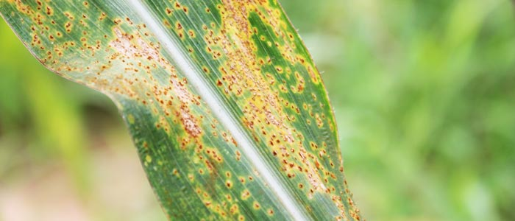

Typical symptoms include dry pustules on lower leaves or a powdery, rust-colored growth. Affected plants may also display brown, purplish, orange, or reddish spots or streaks on the undersides of leaves. Destroy infected plants to prevent spread and keep the area free of debris. A **fungicide registered for use against rust**may help.

## **Mosaic virus**

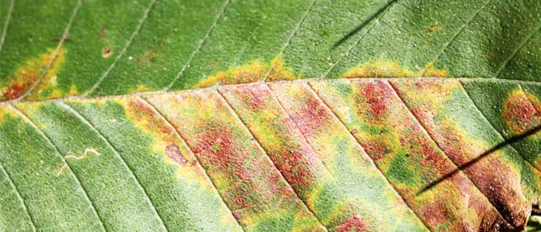

Plants affected by this common viral disease show stunted growth and curled leaves mottled with streaks or spots of white, yellow or green. Unfortunately, mosaic virus is incurable and infected plants should be destroyed. To prevent spread, use **insecticidal soap or neem oil**to control aphids, which may carry the disease.

## **Verticillium Wilt**

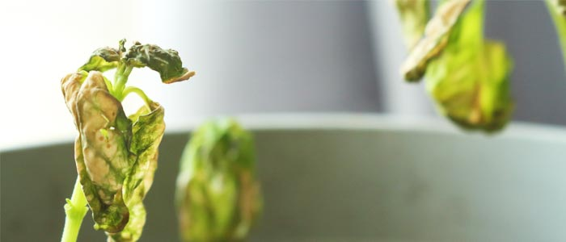

This fungal disease causes a wilted appearance and  yellowing and drooping leaves and stems, usually showing up first on outer or lower leaves. Yellow patches eventually turn brown and cover entire leaves before they drop and the plant dies. There is no effective treatment for verticillium wilt. **Destroy badly infected plants**and avoid planting similar plants in the same area for at least four years.

BANANA

### Moko disease/bacterial wilt

**Disease symptoms**

* 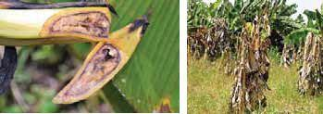Leaves become yellow and progress upwards. The petiole breaks and leaves hang.
* When it is cut open discolouration in vascular region with pale yellow to dark brown colour.
* The discolouration is in the central portion of the corm.
* Internal rot of fruits with dark brown discoloration.
* When the pseudostem is cut transversely bacterial ooze can be seen.

**Survival and spread**

* The bacterium survives in infected plant material, vegetative propagative organs, wild host plants, and soil.

**Favourable conditions**

* High temperatures and high soil moisture generally favors disease

### Tip over or bacterial soft rot

**Disease symptoms**

* 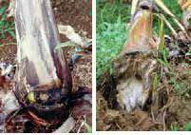This disease is more pronounced on young suckers leading to rotting and emitting of foul odor
* Rotting of collar region is a commonest symptom followed by epinasty of leaves, which dry out suddenly
* If affected plants are pulled out it comes out from the collar region leaving the corm with their roots in the soil
* In early stage of infection dark brown or yellow water soaked areas are more in the cortex area When affected plants are cut open at collar region yellowish to reddish ooze is seen.

**Survival and spread**

* Bacteria survive in crop debris and infect by water splash through damaged tissues.
* Worse in hot wet weather. The bacteria spread in contaminated water.

**Favourable conditions**

* Higher temperatures and high humidity are ideal growing conditions for the bacteria

### Infectious chlorosis (CMV)

**Disease symptoms**

* 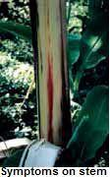The disease manifests itself in all stages of crop growth.
* Due to repeated use of suckers from infected plants the disease spreads and resulting in the gradual decrease in yield and quality.
* The disease is known to occur in all banana-growing states.
* Light yellow streaks run parallel to leaf veins giving the leaf a striped appearance.
* The streaks run usually from mid rib to edge of the blade.

**Survival and spread**

* Virus is disseminated by suckers and Aphis gossypi.

## **Citrus Diseases**

**Citrus Canker**

[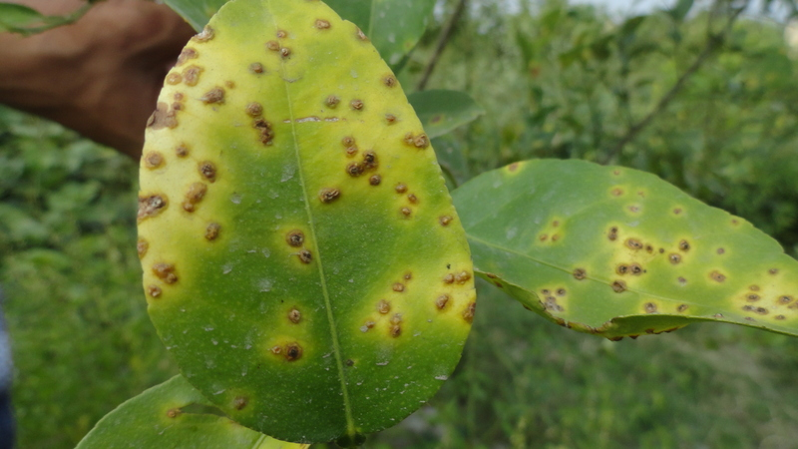](https://s3.amazonaws.com/plantvillage-production-new/images/pics/000/063/011/original/DSC00068.jpg?1467048028)

*Symptoms on leaves*

[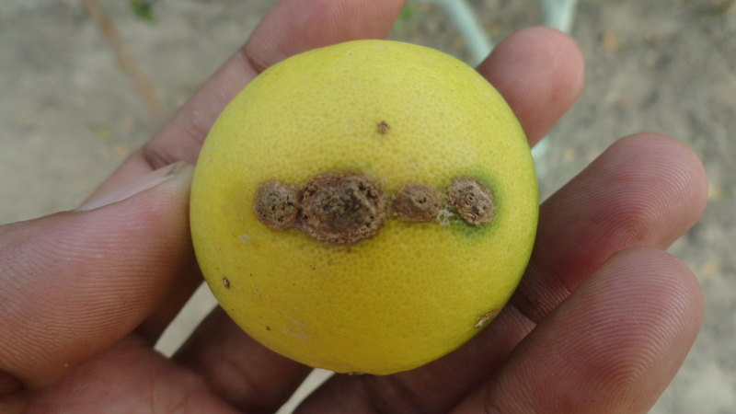](https://s3.amazonaws.com/plantvillage-production-new/images/pics/000/063/012/original/DSC00099.jpg?1467048029)

*Symptoms on fruit*

Citrus canker is a highly contagious bacterial infection of citrus trees causing yellow halo-like lesions or scabs on the fruit, leaves and twigs of citrus trees. Severe infections can cause leaf loss, blemished fruit, fruit drop and die back. It is caused by the bacterium Xanthomonas citri. Bacteria survive in lesions.They spread easily and quickly on air currents, insects, birds and on humans by means of clothing and infected implements. There are a variety of sprays designed to protect against infection including using [Liquid Copper Fungicide](https://www.treehelp.com/liquid-copper-fungicide-spray/) as a preventative treatment, especially when citrus canker has been detected in the area. Unfortunately, already infected trees are generally destroyed quickly to slow down the spread of the bacteria.

**Favorable** environmental **conditions**

axonopodis declines after the first event of wind-blown rain dispersal. Apart from that, the bacteria also favor warm weather. The cases of **citrus canker** are more acute in areas that receive high rainfall and have high mean temperature

**Greasy Spot**

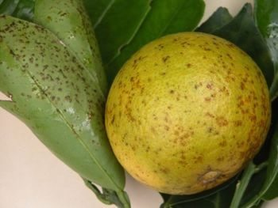

The symptoms are caused by the fungus Mycosphaerella citri, which survives in crop debris on the soil surface when no **suitable** crop is available. In the spring, when **conditions** are **favorable**, the fungus produces spores that are released by rain splashes, overhead irrigation or heavy dew.

Greasy spot is another fungus disease of citruses. Telltale signs include yellowish-brownish blister spots on leaves, often on the underside of the leaf. As the disease develops, the spots develop into oily looking blisters. Greasy spot can cause significant leaf loss, particularly during winter and can also infest citrus, particularly grapefruit, rind. To control Greasy Spot, regularly collect and remove any fallen leaves, thus reducing the source of new spores. Spay the tree with [Liquid Copper Fungicide](https://www.treehelp.com/liquid-copper-fungicide-spray/) in June or July. A second spray application may be needed to be applied in August or September to protect late-summer growth.

**Citrus Whitefly**

### *Dialeurodes citri* (*Ashmead*)

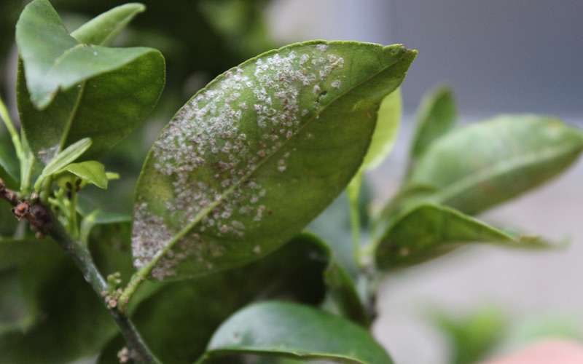

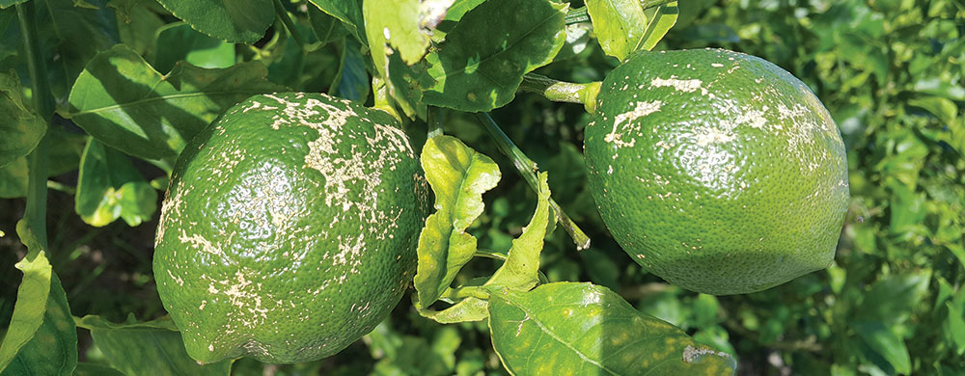

The citrus whitefly is a tiny white winged insect that is about 1/12 of an inch in length. It is most commonly found feeding on the underside of the tree’s leaves. When the branches are shaken, the Citrus whitefly will rapidly take flight and can be seen fluttering around the tree. In addition to feeding on the citrus tree, the whiteflies also lay their eggs on the underside of the leaves. When the eggs hatch, the juveniles are small oval, almost transparent larva, which attach themselves to the underside of the leaves and begin sucking the sap from the leaves. As a result, the tree’s leaves begin to curl and appear to be covered with a sticky, sooty mold substance.

The mold like substance is actually honeydew that is excreted by the whiteflies because they are not able to metabolize all of the sugars contained in the leaf sap. The honeydew can often be seen dripping from the tree’s leaves and becomes an attractant to other insects such as ants.

Over the growing season, several generations of whiteflies can emerge.

**Whiteflies** develop rapidly in warm weather, and populations can build up quickly in situations where natural enemies are ineffective and when weather and host plants favor outbreaks.

To effectively control Citrus Whiteflies spray the tree with [Bug Buster](https://www.treehelp.com/itemdesc.asp?ic=LG-6400) or [Trounce](https://www.treehelp.com/itemdesc.asp?ic=WS-TROUNCE). It is hard to achieve full control of the adult flies, but several sprayings of the tree with either Trounce or Bug Buster will significantly reduce the juvenile population and in doing so the overall population.

**Orangedog Caterpillars**

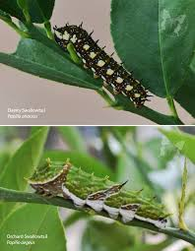

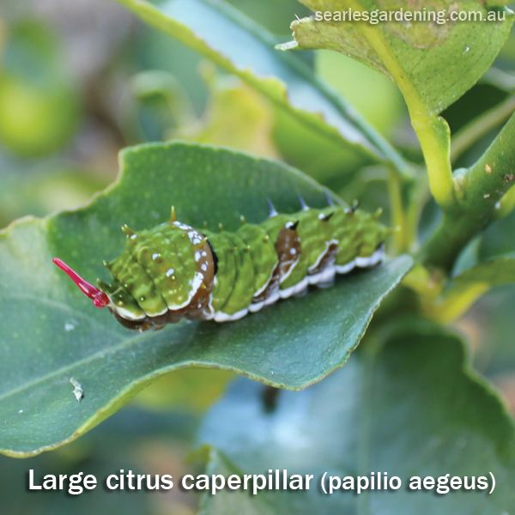

Period of Primary Occurrence: April through September

The Orangedog caterpillar is a large caterpillar about 1.5 to 2 inches in length. Its body is a brown color. The caterpillar attaches citrus trees by eating the tree’s leaves. A good indicator that the Orangedog Caterpillar is attacking the tree leaves throughout the tree appear to be partially eaten or chewed from the outer edges.

The caterpillar is the juvenile stage of the black and yellow swallowtail butterfly that is common in most areas of Florida. The adult butterfly lays her eggs on new citrus leaves and as the eggs hatch and new caterpillars emerge, they can very rapidly defoliate an entire tree in on a few days.

To control the Orangedog caterpillar, physically remove and destroy the caterpillars by hand. It is important to note that the caterpillars when disturbed will push out two red hornlike antennas from just behind their head that emit a strong repugnant smell. If the infestation is intense or physically removing the caterpillars is not possible, the Orangedog caterpillar can be controlled by straying the tree with [Garden Insect Spray with Spinosad](https://www.treehelp.com/itemdesc.asp?ic=LG-6150) or [BTK Biological Insecticide](https://www.treehelp.com/itemdesc.asp?ic=WS-5160) Bacillus thuringiensis (Bt). Both of these products are safe to use around the home and garden and are made from a naturally occurring bacteria. Be sure to completely spray the tree. With the BTK a second spraying will likely be required in about 7 to 10 days. With the Garden Insect Spray with Spinosad a second spraying may be required in 3 to 4 weeks, depending on the severity of the infestation.

Best Management Practices (BMP) • Maturing and mature citrus trees can easily withstand the loss of a few leaves • Homeowners may find that just a few larvae of the giant swallowtail will defoliate small, potted citrus plants. It is recommended that caterpillars be hand picked from these small plants so that leaf production and fruit yield are not drastically reduced • Young citrus trees grown in the landscape can become infested with numerous orange dog caterpillars on occasions, especially in instances where there is a single tree growing in a landscape.